Docker & K8 Assignment  
Assignment  
  
4. Setup a Docker-hub account.  
5. Build a Docker Image & push to Docker Hub (Make an Image Public & Share the Image path from  
Docker Hub Repo).

#Build Docker Image Successfully

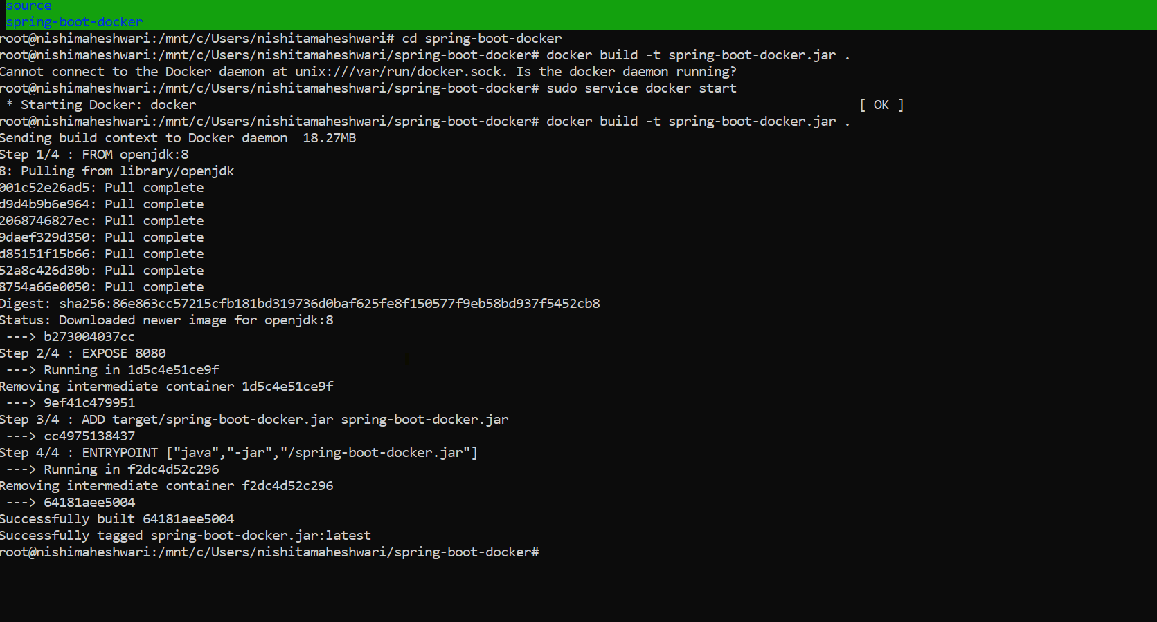

#Latest docker Image

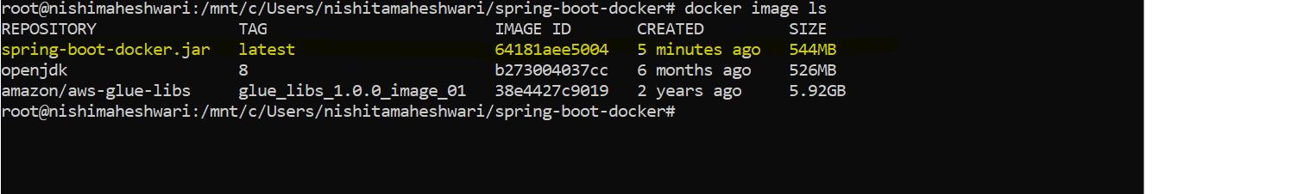

#Login Docker Hub Successfully

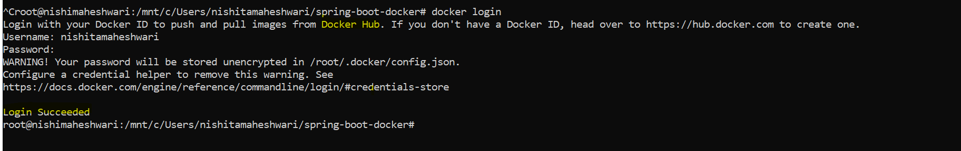

#Adding Username As a tag in image file name

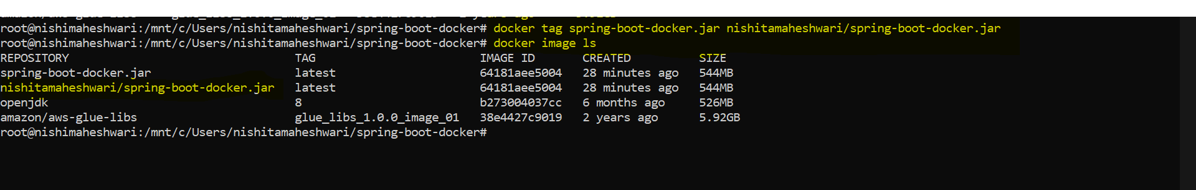

#Image Push to Docker Hub

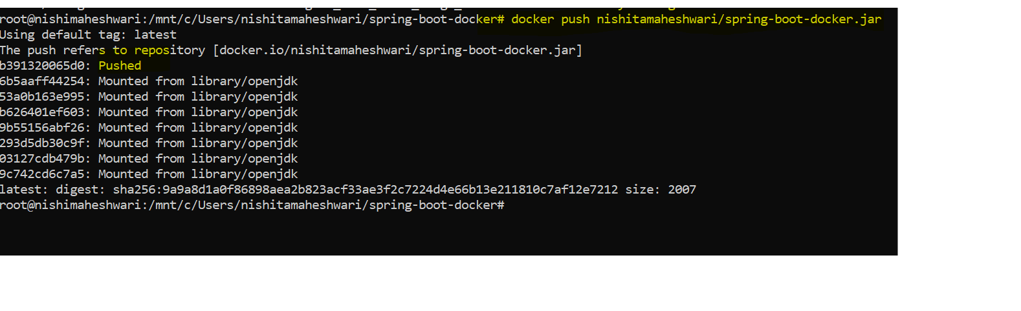

<https://hub.docker.com/u/nishitamaheshwari>